Orion Oaks Fourth Grade
Listed below are the common supplies that all fourth grade classrooms at Orion Oaks Elementary are suggesting. These supplies help the classroom for an entire year! Thank you in advance for supporting your child and their classroom.
General Items
- 5 composition notebooks (wide ruled, 100 pages) **See picture at the bottom
*No spiral notebooks please
- $5.00 for 10-pocket folder—cash only please

- 1 inch binder (3 rings and clear pocket in the front to slide papers in) **see picture at the bottom
(No trapper keepers please)

2 packages (or 1 large package) of each:
Tissues* Expo Markers* Dixon Ticonderoga #2 pencils*
Clorox Wipes* Sticky Notes* (Square, 3in x 3 in and/or square 4in x 4in)
1 pkg of each:
Markers* Post-It brand colored Tabs (not flags)* *See picture at the bottom

*Supplies with an asterisk are community supplies the entire class will use.

Other Appreciated Donations
- Clorox Wipes and/or boxes of tissues *Colored Pens
- Ziploc bags (variety of sizes) *Pencil Top erasers
- Pencils (preferably Ticonderoga) *Markers
- Expo Markers (skinny and thick) * Ream of white/colored copy paper
- Sticky Notes (all sizes) *Highlighters
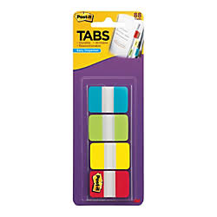
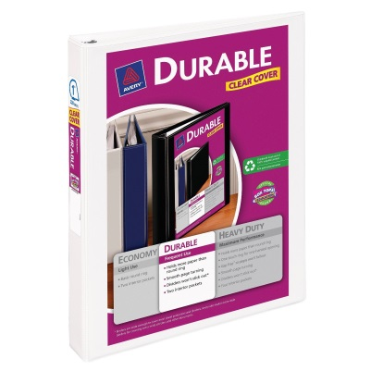
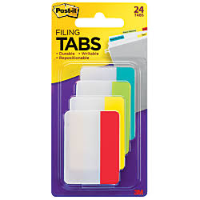
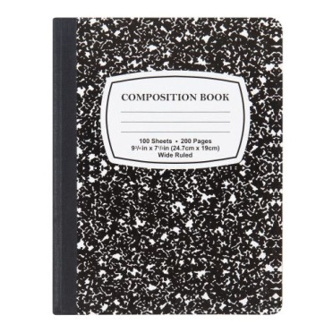
Composition Notebook Clear Cover 1 inch binder Post-It Tabs

